WT LAB ASSIGNMENT 5

QUES 1.

<html>

<head>

<link href="D:\bootstrap-5.1.3-dist\bootstrap-5.1.3-dist\css\bootstrap.min.css" rel="stylesheet">

</head>

<body>

<div class="container">

<div class="row">

<div class="col-xxl-4">

<h1>Alert Box</h1>

<p>Click on the button below for the alert box</p>

<button onclick="alrt()">Click Here</button>

</div>

<div class="col-xxl-4">

<h1>Confirm Box</h1>

<p>Click on the button below for the confirm box</p>

<button onclick="confirmbox()">Click Here</button>

<p id="click"></p>

</div>

<div class="col-xxl-4">

<h1>Promt Box</h1>

<p>Click on the button below for the Promt Box</p>

<button onclick="pbox()">Click Here</button>

<p id="res"></p>

</div>

</div>

</div>

<script>

function alrt(){

alert("This is a alert box");

}

function confirmbox(){

var text;

if(confirm("press a button")){

text="you pressed ok";

}

else{

text="you pressed cancel";

}

document.getElementById("click").innerHTML = text;

}

function pbox(){

let name;

let person=prompt("Enter Your name","your name");

if(person==null || person==""){

name="No Name Entered";

}

else{

name="You entered "+person+"";

}

document.getElementById("res").innerHTML=name;

}

</script>

</body>

</html>

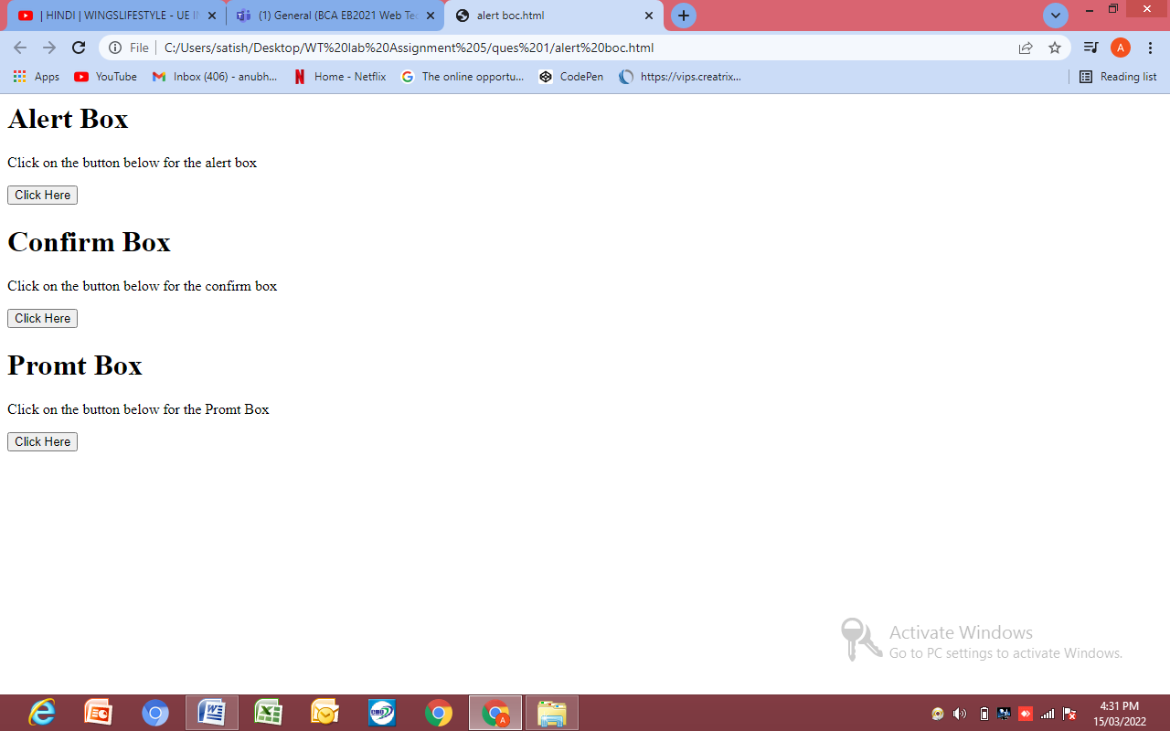

QUES 2

<html>

<head>

<link href="D:\bootstrap-5.1.3-dist\bootstrap-5.1.3-dist\css\bootstrap.min.css" rel="stylesheet">

</head>

<body>

<div class="container">

<div class="row">

<div class="col-xxl-6">

<center>

<H1> OnClick Event</H1>

<p>clcik on the button below to change the image</p>

<img id="img" src="tekken3.jpg" width="250px" height="auto"><br><br>

<button onclick="change()">Click Here</button>

</center>

</div>

<div class="col-xxl-6">

<center>

<h1>Onmouseover and Onmouseout Event </h1>

<p>hover the mouse on the image to change it</p>

<img id="img2" onmouseover="over(this)" onmouseout="out(this)" src="tekken3.jpg" width="250px" height="auto">

</center>

</div>

</div>

</div>

<script>

function change(){

document.getElementById("img").src="tekken4.jpg";

}

function over(x){

x.src="tekken4.jpg";

}

function out(x){

x.src="tekken3.jpg";

}

</script>

</body>

</html>

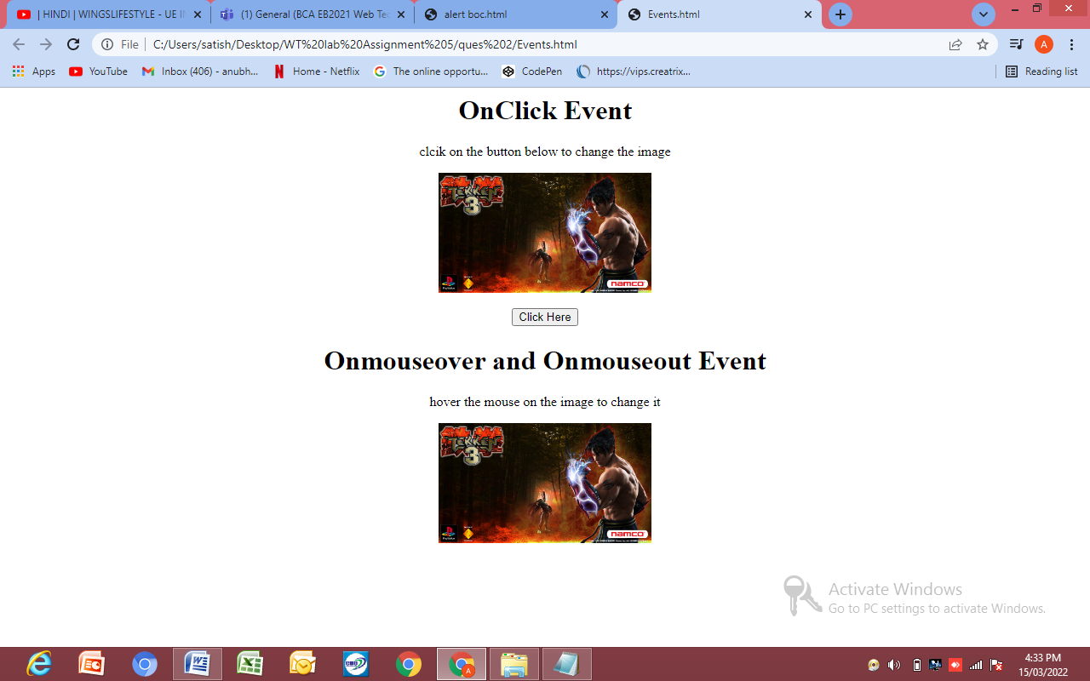

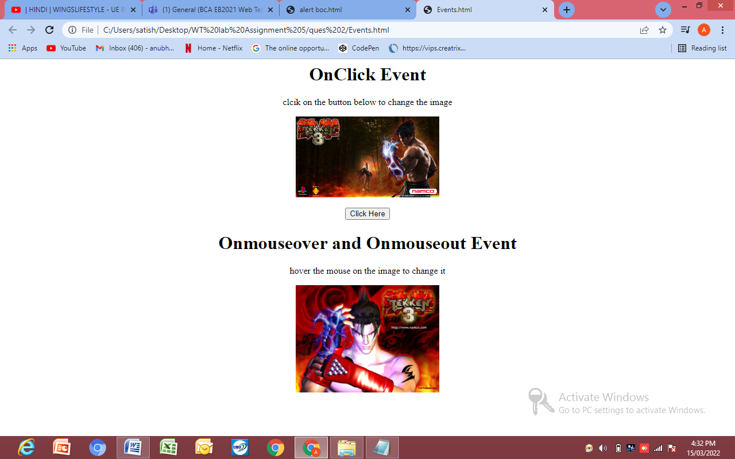

QUES 3

<!DOCTYPE html>

<html>

<head>

<link href="D:\bootstrap-5.1.3-dist\bootstrap-5.1.3-dist\css\bootstrap.min.css" rel="stylesheet">

</head>

<body>

<div class="container">

<div class="row">

<div class="col-xxl-4">

<h2>JavaScript new Date()</h2>

<p id="demo1"></p>

</div>

<div class="col-xxl-4">

<h2>JavaScript Math.pow()</h2>

<p>Math.pow(x,y) returns the value of x to the power of y:</p>

<p id="demo2"></p>

</div>

<div class="col-xxl-4">

<h2>JavaScript Strings</h2>

<p>Strings are written inside quotes. You can use single or double quotes:</p>

<p id="demo3"></p>

</div>

</div>

</div>

<script>

const d = new Date();

document.getElementById("demo1").innerHTML = d;

</script>

<script>

document.getElementById("demo2").innerHTML = Math.pow(8,2);

</script>

<script>

let carName1 = "Volvo XC60"; // Double quotes

let carName2 = 'Volvo XC60'; // Single quotes

document.getElementById("demo3").innerHTML =

carName1 + " " + carName2;

</script>

</body>

</html>

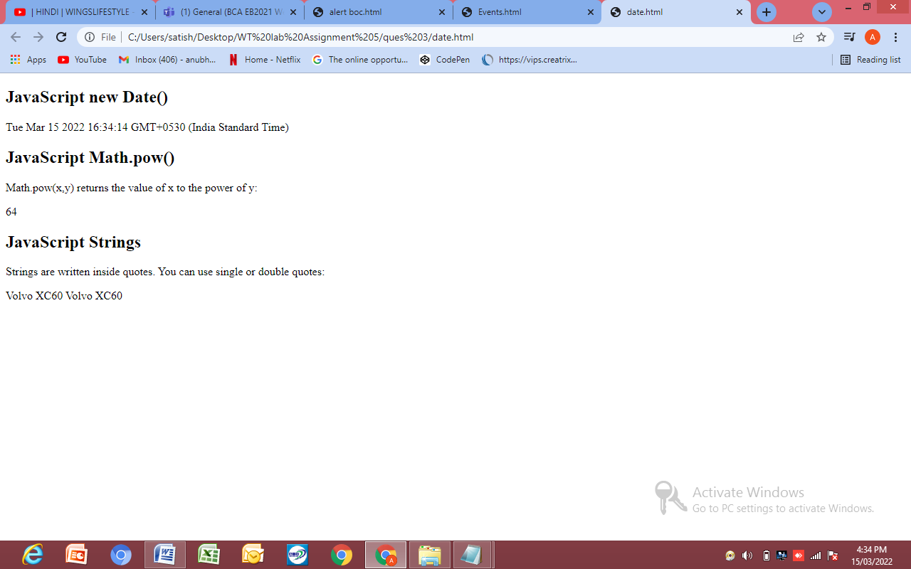

QUES 4

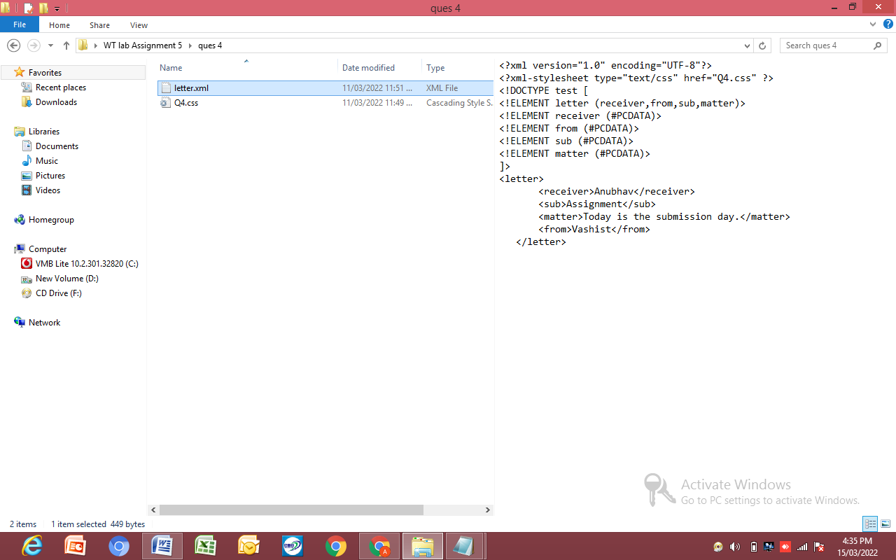

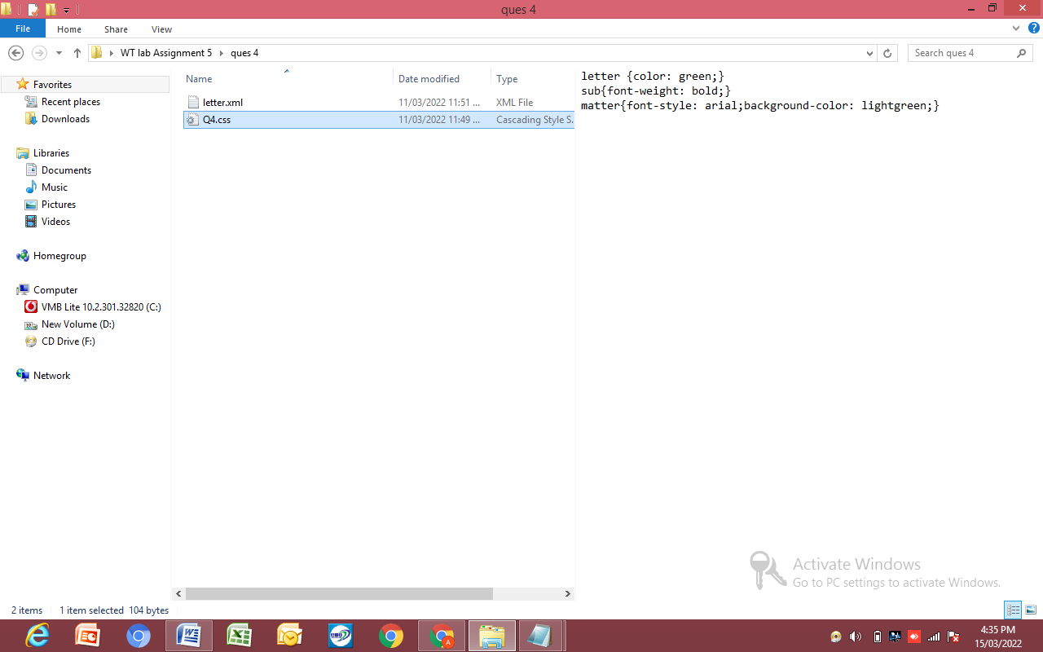

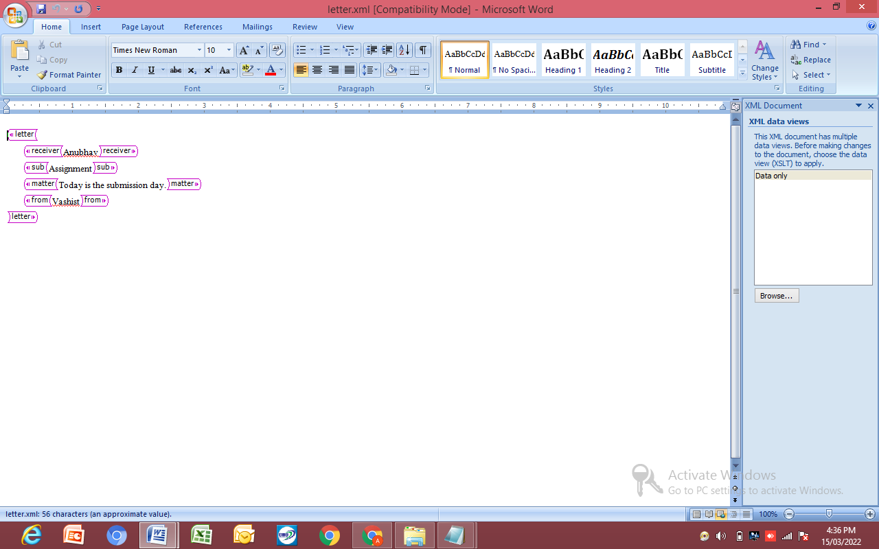

QUES 5

<html>

<head>

<link href="D:\bootstrap-5.1.3-dist\bootstrap-5.1.3-dist\css\bootstrap.min.css" rel="stylesheet">

<style>

tr:nth-child(odd){

background-color:rgb(236, 123, 30);

}

tr:nth-child(even){

background-color:rgb(233, 214, 199);

}

table{margin-top:50px}

body{background-size:cover}

</style>

</head>

<body background="nature.jpg">

<div class="container">

<table class="table">

<tr>

<td>Student</td>

<td>Marks</td>

<td>Rank</td>

</tr>

<tr>

<td>Anubhav</td>

<td>98</td>

<td>1</td>

</tr>

<tr>

<td>Varun</td>

<td>85</td>

<td>8</td>

</tr>

<tr>

<td>Harsh</td>

<td>99</td>

<td>3</td>

</tr>

<tr>

<td>Akash</td>

<td>81</td>

<td>7</td>

</tr>

<tr>

<td>Vikas</td>

<td>69</td>

<td>15</td>

</tr>

</table>

</div>

</body>

</html>

